Sensitivity Analysis

1. Formulate LP model for this problem?

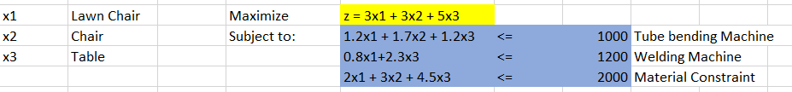

1. Solve the problem using Solver.

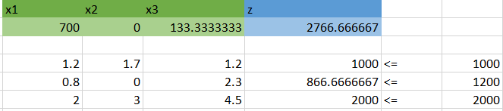

1. What is the optimal production mix? What contribution can the firm anticipate by producing this mix?

Optimal Production Mix:

* 700 units of Lawn Chairs
* 0 Benches
* 133.333 units of Tables

Contributions:

* Lawn Chairs: 700 \* 3 = $2100
* Benches: 0 \* 3 = $0
* Tables: 133.333 \* 5 = $666.6667

The Firm can expect a total profit of $2766.6667.

1. What is the value of one unit more of tube-bending time? of welding time? of metal tubing?

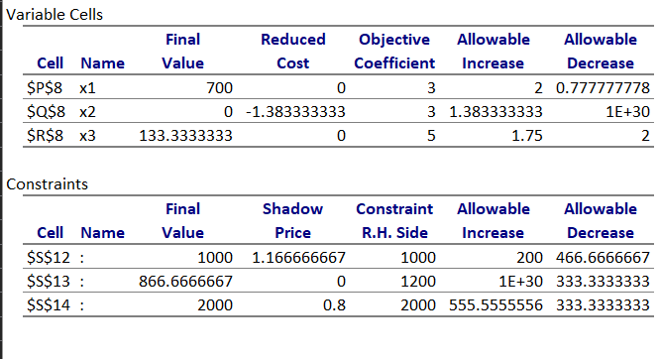

* 1 unit of tube bending time = 1.66667
* 1 unit of welding time = 0
* 1 unit of metal tubing = 0.8

1. A local distributor has offered to sell Outdoors, Inc. some additional metal tubing for $0.60/lb: Should Outdoors buy it? If yes, how much would the firm’s contribution increase if they bought 500 lbs. and used it in an optimal fashion?

The profit gained from one lb of metal tubing is $0.80, which is more than the cost of one lb of metal tubing, $0.60. Therefore, if we buy 500 lb of metal tubing, at a cost of: $300, profit on each lb of metal tubing is $(0.80 – 0.60) = $0.20

Therefore, total profit will be: 0.20 \* 500 = $100

1. If Outdoors Inc. feels that it must produce at least 100 benches to round out its product line, what effect will that have on its contribution?

This adds a new constraint: x2 >= 100

Looking at the sensitivity report, we see that the allowable increase for x2 is 1.38333, and the reduced cost for x2 is -$1.383333

Therefore, if we produce 100 units of x2, we will incur a loss of 100 \* 1.38333 = $138.3333

1. The R&D department has been redesigning the bench to make it more profitable. The new design will require 1.1 hours of tube-bending time, 2.0 hours of welding time, and 2.0 lbs. of metal tubing. If it can sell one unit of this bench with a unit contribution of $3, what effect will it have on overall contribution?

New design will consume resources in the following manner:

* Tube bending: 1.1 \* 1.6667
* Welding: 2.0 \* 0
* Metal Tubing: 2 \* 0.8

Total = $2.88333

Now, the reduced cost for x2 is -$1.383333

Therefore, the contribution is: 2.88333 – 1.38333 = $1.5 per unit of x2 (Bench)

1. Marketing has suggested a new patio awning that would require 1.8 hours of tube-bending time, 0.5 hours of welding time, and 1.3 lbs. of metal tubing. What contribution must this new product have to make it attractive to produce this season?

To make this new patio awning, we need to consume 1.8 hours of tube bending machine, 0.5 hours of welding time, and 1.3lbs of metal tubing.

Therefore, for the patio awning to be profitable, it’s cost must at least be equal to the cost of the resources it consumes. Let us calculate this cost with regard to the original LP formulation, which yielded the shadow prices of x1, x2 and x3 as 1.16667, 0 and 0.8 respectively.

Cost = 1.8\*1.16667 + 0.5\*0 + 1.3\*0.8 = $3.140006

Therefore, each unit of this new item must sell for at least $3.14 for it to be attractive to produce this season.

1. Outdoors Inc. has a chance to sell some of its capacity in tube bending at cost + $1.50/hour. If it sells 200 hours at that price, how will this affect contribution?

We have seen that one unit of tube bending machine brings in a profit of $1.16667, and it can be decreased by 466.6667 units. Therefore, we can assume that renting the machine out will generate an overall profit in the end.

On selling the time of machine 1, we generate a profit of:

1.50 \* 200 = $300

However, when we reduce the time of machine 1 available to the company itself, we will affect the profit generated by manufacturing too.

That loss will be shadow price of Machine 1 times the units we lose

1.166667 \* 200 = $233.3333

However, in total revenue, we will see a profit of 300 – 233.3333 = $66.6667

1. If the contribution on chairs were to decrease to $2.50, what would be the optimal production mix and what contribution would this production plan give?

The original contribution was $3. The decrease is $0.5 which is within the range for allowable decrease. Therefore, the optimal production mix would remain the same.

New contribution: 2.5 \* 700 = $1750